Lab 3
Program to Add Numbers x, y, and z using Function Overloading

Objective
To demonstrate Function Overloading in C# by writing multiple versions of a method called Add that can handle different numbers of parameters.

Approach
Method overloading allows us to define multiple methods within the same class that have the same name but different parameters. This means we can write one method name (like Add) and let it work with different numbers or types of inputs. The C# compiler automatically decides which method to run based on the number and types of parameters we pass.
In this lab session, a C# program having four versions of the Add method: one with no parameters, one with one parameter, one with two parameters and one with three parameters was written and executed. Even though they had the same name, each of them performed the same basic task – addition but with different input combinations.

Results
The following source code shows the use case of Method Overloading in C#
namespace SmritiShrestha.src.SessionThree;
using System;
public class Addition
{
public void Run()
{
Console.WriteLine(Add());
Console.WriteLine(Add(7));
Console.WriteLine(Add(7, 5));
Console.WriteLine(Add(6, 10, 7));
}
public string Add(){
return "No numbers were provided";
}
public string Add(int x){
return "At least two numbers are required to perform addition";
}
public string Add(int x, int y)
{
int result = x + y;
return $"Sum of {x} and {y} = {result}";
}
public string Add(int x, int y, int z)
{
int result = x + y + z;
return $"Sum of {x}, {y} and {z} = {result}";
}
}
class Program
{
static void Main(string[] args)
{
Addition add = new Addition();
add.Run();
}
}
Explanation:
This program includes four Add() methods with different numbers of parameters in the Addition class,. One method handles no input, another handles one number, and the others handle two and three numbers. Each method does something based on how many values are passed—either showing a message or adding the numbers.
The Run() method calls all four versions of Add(), and the results are printed using Console.WriteLine(). In the Main() method, an object of the Addition class is created, and Run() is called to test everything.
Output
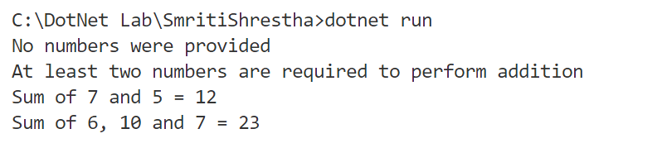
Fig 1: Output of the above program

Upon execution, the following observations were made:
Add(): This method is called when no values are passed. It simply returns a message “No numbers were provided”.
Add(int x): This method is called when only one value is passed. Since addition requires at least two numbers, it returns a message “At least two numbers are required to perform addition”.
Add(int x, int y): This method is called when two values are passed. It adds the two numbers and returns the result in a formatted string: “Sum of 7 + 5 = 12”.
Add(int x, int y, int z): This method is called when three values are passed. It adds the three numbers and returns the result in a formatted string: “Sum of 6 + 10 + 7 = 23”.

Conclusion
This lab session successfully demonstrated the working of method overloading in C#. Even though all methods had the same name, the C# compiler could distinguish between them based on the number of values passed during the method call. For example, when we called Add(7, 5), the compiler automatically matched it to the method that accepts two values. Similarly, Add(6, 10, 7) was matched with the three-parameter version. This helps keep the code clean and organized, especially when different versions of a method are supposed to perform a similar action but with different types or numbers of inputs. This lab session helped us understand that method overloading increases code reusability and readability, as it prevents us from having to create different method names like AddTwoNumbers, AddThreeNumbers, etc. Instead, we can use the same method name and let the compiler handle the correct selection based on numbers and types of parameters.

